An Electronics for COLORES

Martin Kákona at August 2011

There are some simple electronics for COLORES astronomy spectrograph. It controls COLORES machinery and sends telemetry from the device. Because COLORES is a prototyping device the electronics is highly modular based on MLAB kit ([www.mlab.cz](http://www.mlab.cz)). This concept enables adding some new sensor or servo due to project needs operatively.

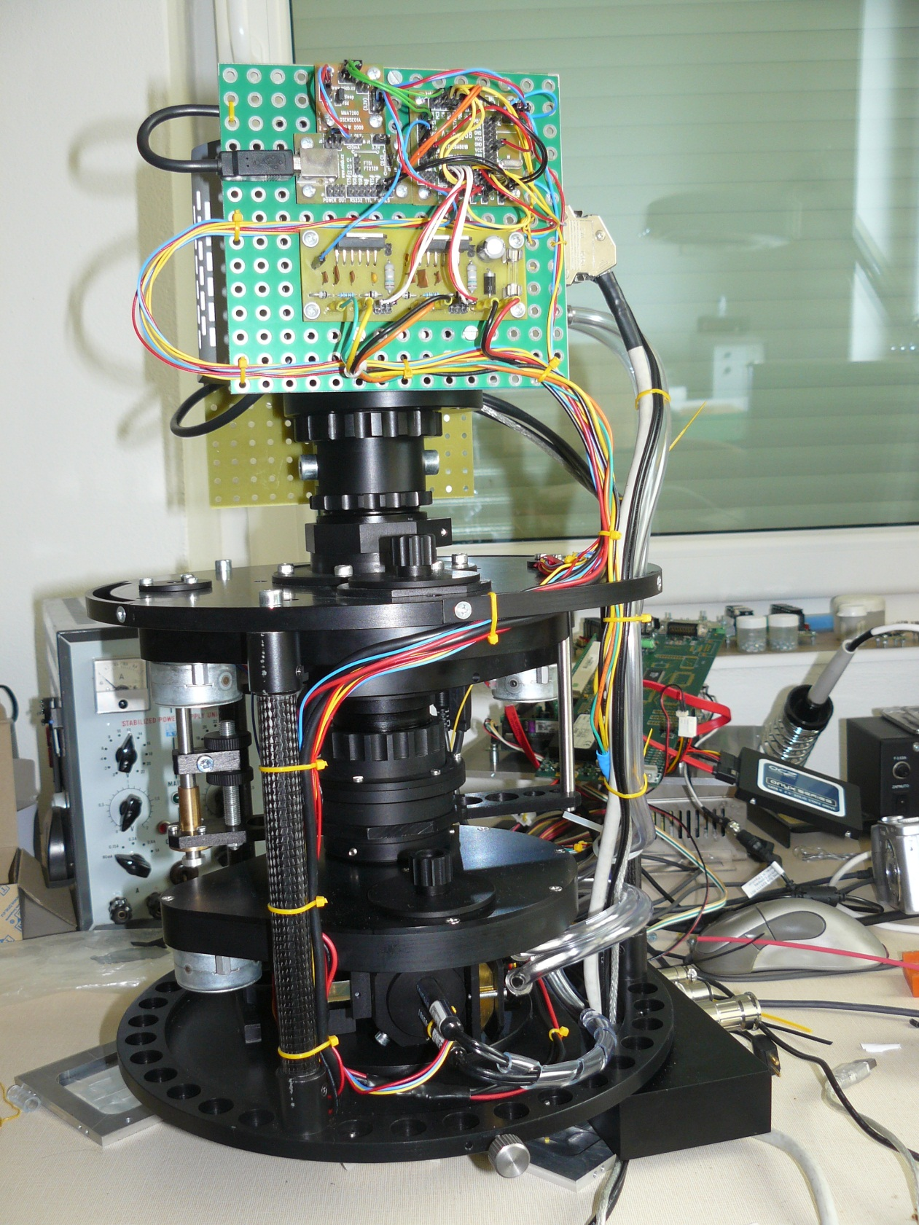

MLAB

Processor

Motor Driver

USB interface

Accelerometer

All electronics developed for COLORES is an Open Source Hardware with public documentation and it is possible remanufacture it or copy documentation with mention about authors.

The electronics is driven by a board with a single chip processor ATmega 328 [ 1 ] which is programmed by Processing language [ 2 ] for simplicity. Processing allows modifying a program to an inexperienced programmer without deep knowledge about electronics. The program can be modified remotely thanks bootloader which is preloaded inside processor.

The single chip processor communicates with a telescope control computer by an USB interface [ 3 ]. The computer can sends commands for changing a mechanical setup of device or it can reads telemetry. The telemetry consists from information from light sensors [ 4 ], temperature sensors   
[ 5 ] and 3-axis accelerometer [ 6 ].

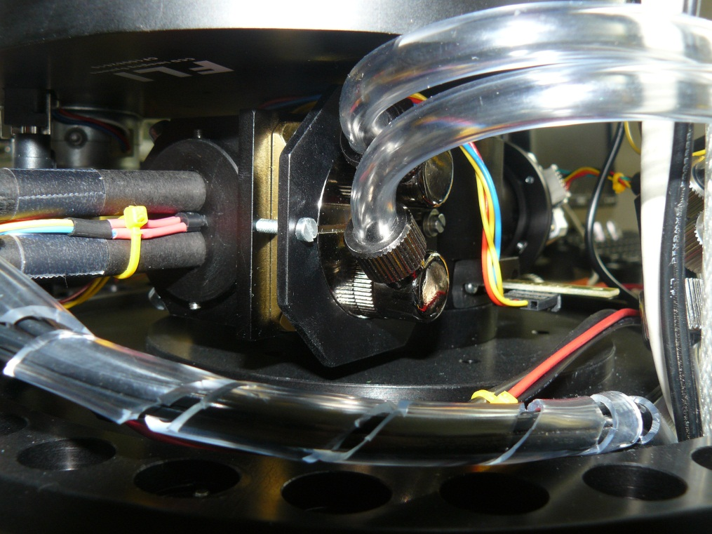

Thermometer

Light sensor

[  ] <http://www.mlab.cz/WebSVN/filedetails.php?repname=MLAB&path=%2FModules%2FAVR%2FATmega801B%2FSCH%2FATMEGA801B_SCH.PDF>

[ ] <http://en.wikipedia.org/wiki/Processing_(programming_language)>

[  ] <http://www.mlab.cz/WebSVN/filedetails.php?repname=MLAB&path=%2FModules%2FCommSerial%2FUSB232R01B%2FSCH%2FUSB232R01B_sch.pdf>

[  ] <http://www.mlab.cz/WebSVN/filedetails.php?repname=MLAB&path=%2FModules%2FSensors%2FISL2902001A%2FSCH%2FISL29020.pdf>

[  ] <http://www.mlab.cz/WebSVN/filedetails.php?repname=MLAB&path=%2FDesigns%2FSpectrograph%2Fpdf%2FDS18B20.pdf>

[  ] <http://www.mlab.cz/WebSVN/filedetails.php?repname=MLAB&path=%2FModules%2FSensors%2FGSENSE01A%2FSCH%2FSCH.pdf>